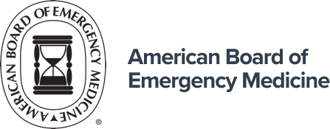

The Dr. Leon L. Haley, Jr. Bridge to the Future of Emergency Medicine Academy
APPLICATION FORM

Name: Email: Phone Number:
Medical School:
Name of Supporting Dean (e.g., Diversity Equity and Inclusion or Medical Education) __________________________________
Dean/Associate Dean Name: ______________________________
Dean/Associate Dean Email: _____________________________

Demographics:

- I identify myself as:
Male
Female
Non-binary

- The following best describes my ethnicity:
American Indian or Alaska Native
Tribal Affiliation: _____________________
Asian
Chinese
Filipino
Indonesian
Japanese
Indian
Korean
Bangladeshi
Cambodian
Laotian
Pakistani
Vietnamese
Other Asian____________________
Black or African American
African American
Afro-Caribbean
African
Other Black____________________
Hispanic, Latino, or of Spanish Origin
Argentinean
Columbian
Cuban
Dominican
Mexican
Peruvian
Puerto Rican
Other Hispanic____________________
Middle Eastern/North African
Multi-Racial_____________________
Native Hawaiian or Other Pacific Islander
Guamanian
Native Hawaiian
Samoan
Other Pacific Islander_____________________
Other (please specify): _______________________
Unknown Race/Ethnicity
White

- I identify myself as:
Man
Woman
Trans man
Trans woman
Agender
Genderqueer/Gender non-conforming
Non-binary
Other (please specify):____________________

Please explain the reason(s) why you would like to participate in the Dr. Leon L. Haley, Jr. Bridge to the Future of Emergency Medicine Academy and what will you hope to gain from
the program:

Describe your journey to and through medical school admission:

Describe your community service experiences:

What makes you uniquely qualified to participate in this program?
List your social media profiles, if any, by providing your handles or links:
- Facebook_________________________________________________________
- Twitter __________________________________________________________
- Instagram________________________________________________________
- LinkedIn__________________________________________________________
- Blogs, podcasts, misc. ______________________________________________

Thank you for your interest in the Dr. Leon L. Haley, Jr. Bridge to the Future of Emergency Medicine Academy.

